**A SUMMER PROJECT REPORT**

**ON**

**FURNITURE SHOP ECOMMERCE WEBSITE**

**FOR**

**HIMALAYAN FURNITURE**

**BY**

**Bishal Dhakal**

**T.U. Registration No:7-2-410-202-2020**

**Exam RollNo:11721/20**

Prime College

*A Summer Project Report Submitted to*

**Faculty of Management, Tribhuvan University**

in partial fulfillment of the requirements for the degree of

**Bachelor of Information Management**

Kathmandu

June/2024

STUDENT DECLARATION

This is to certify that I have completed the Summer Project entitled “Furniture Shop Ecommerce Website” under the guidance of “**Er.Rolisha Sthapit**” in partial fulfillment of the requirements for the degree of **Bachelor of Information Management** at Faculty of Management, Tribhuvan University. This is my original work and I have not submitted it earlier elsewhere.

Date: …………………

Bishal Dhakal

CERTIFICATE FROM THE SUPERVISOR

This is to certify that the summer project entitled “Furniture Shop Ecommerce Website” is an academic work done by “**Bishal Dhakal**” submitted in the partial fulfillment of the requirements for the degree of **Bachelor of Information Management** at Faculty of Management, Tribhuvan University under my guidance and supervision. To the best of my knowledge, the information presented by him in the summer project report has not been submitted earlier.

……………………

Er. Rolisha Sthapit

Project Supervisor

Date:

ACKNOWLEDGEMENT

I want to express my sincere gratitude to the faculty of Management, Tribhuvan University, for providing the guidelines for the Bachelor of Information Management (BIM) degree. This summer project holds significant academic importance for BIM students.

I extend my thanks to my supervisor, **Er. Rolisha Sthapit**, for granting me the opportunity to create this report and complete the project. Without her support, this project would not have been possible. Her guidance and encouragement played a crucial role in its completion.

I also appreciate the assistance of my colleagues and mentors who shared their knowledge, ideas, and opinions during the project, contributing to its successful execution.

EXECUTIVE SUMMARY

With the rapid growth of e-commerce, the acceptance of online shopping has significantly increased. This paper proposes an e-commerce platform for Himalayan Furniture, designed to expand customer choice and convenience by allowing purchases of a wide array of furniture products with just a click. The platform aims to provide a seamless and efficient shopping experience, leveraging digital technology to enhance business operations. It involves developing a comprehensive website where users can browse the catalog, search for products, add items to their cart, place orders, and make secure payments either online or offline. The system generates detailed bills for each purchase, which customers can print. Administratively, the platform offers robust tools for managing orders, tracking user activity, and maintaining accurate inventory records. Admins also have access to comprehensive sales data for strategic decision-making. The development of the Himalayan Furniture E-commerce System utilized technologies such as PHP for server-side scripting, MySQL for database management, and HTML, CSS, and JavaScript for the client-side interface. This combination ensures a robust, secure, and user-friendly platform. The system streamlines the furniture purchasing process, enhances operational efficiency, and provides a scalable solution for business growth. By moving online, Himalayan Furniture can reach a wider audience, improve customer satisfaction, and increase sales potential.

**Keywords**: *E-commerce Platform, Online Furniture Store, Payment Gateway.*

TABLE OF CONTENTS

*TITLE PAGE i*

*STUDENT DECLARATION ii*

*CERTIFICATE FROM THE SUPERVISOR iii*

*ACKNOWLEDGEMENT iv*

*EXECUTIVE SUMMARY v*

*TABLE OF CONTENTS vi*

*LIST OF FIGURES viii*

*LIST OF TABLES ix*

*LIST OF ABBERVIATIONS x*

CHAPTER 1 INTRODUCTION 1

1.1 Background Study 1

1.2 Introduction of organization 2

1.3 Current situation of the Organization 2

1.4 Statement of the Problem 2

1.5 Objective of the Study 3

1.6.1 Scope 3

1.6.2 Limitation 3

1.7 Methodology of Study 3

1.7.1 Analysis of the problems 4

1.7.2 Data Collection and Analysis 4

1.7.3 Tools Used 5

CHAPTER 2 ANALYSIS OF ACTIVITIES DONE AND PROBLEM SOLVED 6

2.1 Analysis of Current System 6

2.2 Feasibility Analysis 6

2.2.1 Economic Feasibility 7

2.2.2 Technical Feasibility 7

2.2.3 Operational Feasibility 7

2.2.4 Schedule Feasibility 7

2.3 Requirements Analysis 8

2.3.1 Requirement Collection methods 8

2.3.2 Functional Requirements of the system 9

2.3.3Non-Functional Requirement of the System 10

2.4 System Design 10

2.4.1 System architecture 11

2.4.2 DFD Level 0 Diagram 12

2.4.3 DFD Level 1 Diagram 12

2.4.4 DFD Level 2 Diagram 13

2.4.5 ER Diagram 15

2.4.6 Database Schema 16

2.5 System Implementation 17

2.5.1 System Development Methodology Used 17

2.5.2 Modules Description 19

2.6 System Testing 21

2.6.1 Unit testing with test cases 21

2.6.2 Integration testing with test cases 26

CHAPTER 3 DISCUSSION AND CONCLUSION 27

3.1: Conclusion 27

3.2: Lesson Learnt 27

3.3: Recommendations 28

REFERNCES 29

APPENDICES a

LIST OF FIGURES

Figure 1: Gantt Chart 8

Figure 2: Use Case Diagram of Himalayan Furniture 9

Figure 3: System Architecture of Himalayan Furniture 11

Figure 4: DFD Level 0 of Himalayan Furniture 12

Figure 5: DFD Level 1 of Himalayan Furniture 13

Figure 6: DFD Level 2 of Himalayan Furniture 15

Figure 7: ER diagram of Himalayan Furniture 16

Figure 8: Database Schema of Himalayan Furniture 17

Figure 9: Agile Software Development 18

s

LIST OF TABLES

Table 1: Test Case for Admin Loging and Logout 22

Table 2: Test Case for User Registration/Signup 22

Table 3: Test Case for User Login and Logout 23

Table 4: Test Case for Search 24

Table 5: Test Case for add to cart 24

Table 6: Test Case for Order 25

Table 7: Test Case for Integration 26

LIST OF ABBERVIATIONS

CSS Cascading Style Sheet

DFD Data Flow Diagram

ERD Entity Relation Diagram

FK Foreign Key

HTML Hyper Text markup Language

JS JavaScript

PHP Hypertext Preprocessor

PK Primary Key

SQL Structured Query Language

TC Test Cases

UI User Interface

# CHAPTER 1

# INTRODUCTION

## **Background Study**

Information Technology has revolutionized human life by simplifying various tasks through numerous applications. With rapid advancements in IT, many tools, technologies, and systems have emerged. In today's fast-paced world, integrating processes and creating paperless environments ensure efficient task management. Businesses are increasingly adopting computer-based systems to increase market share and offer user-friendly experiences. This project focuses on developing an E-commerce website for Himalayan Furniture using HTML, CSS, JavaScript, MySQL, and PHP. This system aims to make furniture shopping more efficient and easier for both customers and administrators.

The project titled “Himalayan Furniture E-commerce Website” is an online platform designed to manage and control transactions for a furniture store. It automates manual processes involved in running a furniture business. Developed using HTML for creating webpages, CSS for styling, JavaScript for interactivity, MySQL for database management, and PHP for server-side scripting, this system supports key functionalities like adding new products, updating product information, searching for products, and handling customer orders. It also provides both online and offline payment options.

This “Himalayan Furniture E-commerce Website” is a web application designed to help users browse, select, and purchase furniture online. This website is user-friendly for both beginners and advanced users, featuring a familiar and intuitive user interface. Users can browse and filter through a diverse range of furniture items, view detailed information about each product, register and log in, add products to their shopping cart, place orders, and choose between online payment via e-sewa or cash on delivery. They can also view their order history and contact customer support for inquiries or issues. This Himalayan Furniture E-commerce Website aims to provide a seamless and satisfying shopping experience, ensuring users can easily find and purchase the furniture they need.

## **Introduction of organization**

Himalayan Furniture is your destination for exquisite and quality furniture pieces that elevate your living spaces. Which take pride in offering a curated collection that blends functionality with aesthetic appeal. At Himalayan Furniture, we aim to provide a seamless and enjoyable shopping experience, ensuring that each piece complements your unique style and preferences. Discover the perfect furniture for your home with Himalayan Furniture—where quality meets comfort in every piece.

## **Current situation of the Organization**

As of the latest update, Himalayan Furniture continues to thrive as a go-to destination for premium furniture solutions. With a commitment to excellence, Himalayan Furniture maintains a diverse and high-quality product range that caters to various styles and preferences. The store's user-friendly approach and dedication to customer satisfaction make it a preferred choice for those seeking top-notch furniture. In the current market, Himalayan Furniture stands out as a reliable and trusted provider, ensuring customers find the perfect pieces to enhance their living spaces.

## **Statement of the Problem**

* What is the current system for Himalayan Furniture?

The existing system is manual, requiring staff to maintain various records for customers and transactions.

* What is the solution proposed for these issues?

A computerized e-commerce website for Himalayan Furniture aims to streamline these processes.

* How will the new system improve operations?

The new system will enable fast transactions for searching products, placing orders, and generating accurate reports, thereby increasing efficiency, reducing paperwork, and improving transparency.

* What will be the overall impact of the transition to an e-commerce platform?

The transition will simplify the online shopping experience, present a diverse range of furniture products effectively.

## **1.5 Objective of the Study**

Furniture Shop Ecommerce Website provides solutions to help customers find and acquire their desired furniture items with utmost satisfaction. While there are various objectives, the key goals include:

• To enhance the shopping experience for customers by providing a website platform to

browse and purchase of furniture.

• To modernize Himalayan Furniture by adding a secure payment gateway and sending

order confirmation emails to customers.

**1.6 Scope and Limitations**

### **1.6.1 Scope**

The ecommerce website for the furniture shop can be adopted by various non-profit organizations seeking to provide affordable and satisfactory furniture options to the community. Users, with authenticated usernames and passwords, can access the system to explore details about furniture products and categories. Every user has the ability to register, log in, and purchase furniture items through the website. The primary goal of this system is to cater to the diverse furniture needs of customers, ensuring a satisfying and accessible shopping experience for furniture enthusiasts.

### **1.6.2 Limitation**

There are some criteria that may not be fulfilled by my web application implemented. Some of such limitations of my project are mentioned below:

* There is no one time password functionality.
* Lack of customer ratings restricts informed decision-making.
* Absence of wishlists functionality limits users from saving desired items.

## **1.7 Methodology of Study**

This methodology section provides a systematic and theoretical analysis of the methods applied in this study on the development of an ecommerce website for Himalayan Furniture. It involves detailing the research design, approach, sample size, sampling techniques, sampling criteria, and description of tools, all crucial for analyzing and generating findings relevant to the research topic.

### **1.7.1 Analysis of the problems**

This project begins with a detailed examination of the issues faced by Himalayan Furniture due to the lack of an online store, which limits customers' ability to browse and purchase furniture conveniently from home. This analysis will assess the impact on customer experience and business operations, highlighting the inconvenience to customers and potential loss of sales to competitors with online platforms. The absence of an online presence restricts the display of the full product range, complicates inventory management, and hinders effective use of digital marketing strategies. By addressing these challenges, the project will develop a comprehensive plan to build an intuitive and user-friendly online store. This plan will include market analysis, user experience design, technical infrastructure, inventory management, customer support, and a digital marketing strategy. The goal is to enhance customer convenience, improve operational efficiency, and drive business growth for Himalayan Furniture.

### **1.7.2 Data Collection and Analysis**

To create the Himalayan Furniture online store, this project begins by collecting and studying information. This includes finding out what furniture people like, identifying any issues Himalayan Furniture faces, and understanding what customers want.

**Primary Data Collection**

**Direct Interviews:**

Direct interviews are conducted with a variety of stakeholders, encompassing potential customers, industry experts, and key stakeholders. These interviews employ diverse methods such as face-to-face interactions, phone calls, or online video conferences. Through this approach, firsthand qualitative feedback is collected, allowing for insights into user preferences, pain points, and desired features for the e-commerce platform.

**Observations:**

Careful observation of Himalayan Furniture's operations and workflows was conducted to gain an in-depth understanding of the business's daily functioning. This method enabled the identification of inefficiencies and potential areas for improvement within the current system. By closely monitoring interactions between staff, customers, and existing processes, context-specific insights were gathered into the daily challenges faced by both staff and customers. These observations revealed specific pain points and operational bottlenecks, which are critical for informing the development of the eCommerce platform. The insights gained through this method are essential for creating an online store that effectively addresses these issues, thereby enhancing the overall efficiency and user experience of Himalayan Furniture.

**Secondary Data Collection**

**Examination of Past Sales Data:**

For the examination of past sales data, data analysis tools such as Excel and Google Sheets tailored for analyzing historical sales data are utilized. These tools facilitate the identification of trends, customer preferences, and areas for improvement based on past performance. Delving into historical sales data provides valuable insights, enabling informed decision-making and strategic planning for the enhancement of the e-commerce platform tailored to the unique needs and preferences of Himalayan Furniture's customers.

### **1.7.3 Tools Used**

**HTML:** Used for structuring the content on the web pages.

**CSS:** Used for styling the HTML elements.

**JavaScript:** A scripting language used to create dynamic and interactive content on the website. JavaScript is essential for tasks like form validation, interactive maps, and dynamic content updates without reloading the page.

**PHP:** A server-side scripting language used to manage the backend operations. PHP is used for tasks like data processing, session management, and interaction with the database.

**MySQL:** An open-source relational database management system used to store and manage the data. MySQL handles user data, product information, orders, and other critical information that the e-commerce platform needs to function.

**Visual Studio Code:** A powerful, open-source code editor used for writing and debugging code. VS Code supports a variety of programming languages and comes with numerous extensions that enhance productivity, such as syntax highlighting, code snippets, and integrated terminal.

**Draw.io:** A web-based diagramming tool used to create DFD diagram, ER diagrams, use case diagram, and other types of visual documentation. Draw.io helps in visualizing the system architecture, database schemas, and process flows.

# CHAPTER 2

# ANALYSIS OF ACTIVITIES DONE AND PROBLEM SOLVED

## **2.1 Analysis of Current System**

The existing system for Himalayan Furniture is manual, requiring staff to maintain various records of customers and transactions. However, the absence of a website for product showcasing, online ordering, and payment poses a significant limitation for Himalayan Furniture.

**Digitalization:**

Switching from manual methods to automated systems allows Himalayan Furniture to remove paperwork and tedious data entry. By digitizing processes like order management, payment processing, and customer data management, the website streamlines operations, reduces errors, and improves overall efficiency. Customers can easily browse products, place orders, and make payments online, enhancing their shopping experience.

**Product Showcase:**

The Himalayan Furniture ecommerce platform is like a digital showroom where customers can see pictures and descriptions of each product. This helps customers get a good idea of what they're buying and makes it easier for them to choose the furniture that suits their needs and preferences.

**Order Online:**

The Himalayan Furniture ecommerce platform allows customers to purchase furniture items directly from the website. They can browse through the available products, select the ones they want to buy, and proceed to checkout and can pay both online and offline. This convenient process eliminates the need to visit a physical store and provides customers with the flexibility to shop from the comfort of their homes.

## **2.2 Feasibility Analysis**

Feasibility Study is the test of the system according to its work ability, impact on the current system, ability to meet the needs of the current users and effective use of the resources. Its main objective is not to solve the problem, but to acquire its scope. Its focuses on following:

**2.2.1 Economic Feasibility**This web application is available and accessible via the Internet which makes it economically feasible. Users only require an Internet connection to access contents included in the web application. Moreover, there are no charges of any sorts associated with contents in the web application. Hence, the economic expenditure on hardware and manpower required are less. Also this website is able to earn money through advertisements, order placements and user traffic on the site. This system provides many benefits for e.g. user friendliness, more efficient user response, maintenance of database, etc.

### **2.2.2 Technical Feasibility**

This web application requires laptop or PC for hardware and a code editor and browser in

that hardware which is easily available, browsers can be installed easily in that device and the language required to develop the project can be learned easily. This web application is supported by almost all latest web browsers, and most of all, it can be run on modern day systems. So, this project is technically feasible.

### **2.2.3 Operational Feasibility**

This web application is highly user friendly and it is much easier to interact with the user. User does not need special training to operate the system. This web application solves problem faced by the target group that was underlined as the problem statement. This target users can look up to the web application if and when the problem arises. Furthermore, features such as rich information density, efficiency and cost effective is testament to the fact that the web application is operationally feasible.

### **2.2.4 Schedule Feasibility**

The Schedule for this work was created prior the project started. This project was completed within the framed time period. Different tasks were performed for the completion of this project before the deadline which generally fulfill the schedule feasibility. Gantt chart was made to calculate the time frame required to build this project with specific deadlines for the different works. It is necessary to determine if the deadlines are mandatory or desirable.

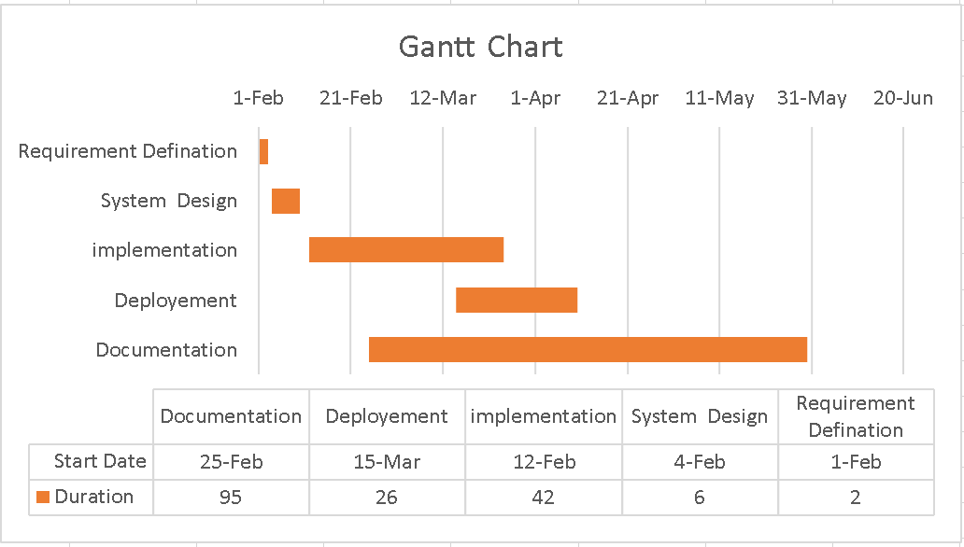

Figure 1:Gantt Chart

## **2.3 Requirements Analysis**

The requirements are to be collected before starting projects’ development life cycle. To design and develop system, functional as well as non-functional requirement of the system has been studied.

### **2.3.1 Requirement Collection methods**

To collect requirements for building the Himalayan Furniture ecommerce website, various methods were employed. Surveys were conducted among potential customers to gather insights into their preferences and expectations. Interviews with stakeholders, including customers and employees, provided valuable feedback on desired features and functionalities. Observations were made on user behavior on competitor websites to gain insights into industry trends and best practices. Focus groups were organized to delve deeper into specific aspects of the website, while requirement workshops involving key stakeholders facilitated brainstorming and consensus-building. By utilizing these methods, a comprehensive understanding of the requirements for the ecommerce website was achieved, ensuring its alignment with user needs and business objectives.

### **2.3.2 Functional Requirements of the system**

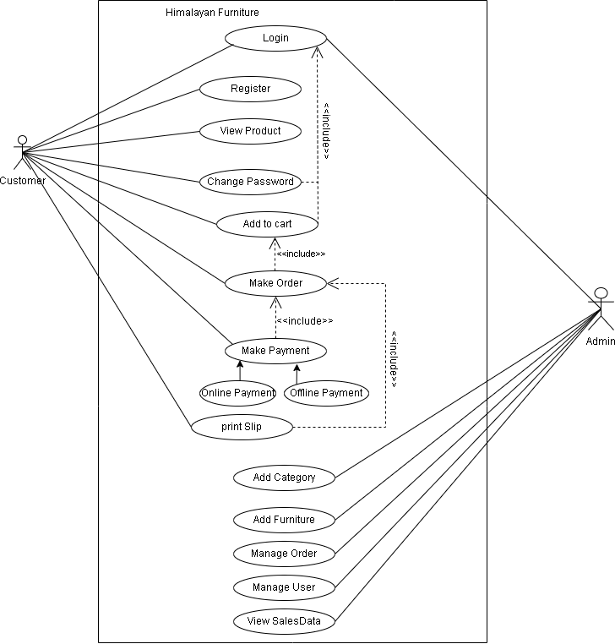

Figure 2:Use Case Diagram of Himalayan Furniture

Functional requirements for a furniture shop ecommerce website:

**For visitors/users:**

* Users can browse products without logging in and create accounts for order tracking.
* Users can add items to their cart, check out securely, and receive order notifications.
* Users can print/download their order products bill.

**For administrators:**

* Admins manage product listings, inventory, and pricing through a dashboard.
* They can add, edit, and delete products and categories.
* Admins can manage orders and customers.
* Admins can track order and sales performance.

### **2.3.3Non-Functional Requirement of the System**

Non-Functional Requirements for the Himalayan Furniture shop ecommerce website:

* **Usability**

The website is easy to use and navigate, making it simple for customers to find and purchase furniture.

* **Reliability**

It accurately manages product listings and inventory, ensuring that customers can trust the information displayed on the website.

* **Performance**

The website loads quickly and operates smoothly, even during busy periods, providing a hassle-free shopping experience.

* **Supportability**

It works well on different devices and web browsers, ensuring that customers can access the website from anywhere.

* **Security and Privacy**

The website keeps customer data safe and secure, preventing unauthorized access and maintaining privacy.

## **2.4 System Design**

For the system design phase of the Himalayan Furniture project, Data Flow Diagrams (DFDs) have been utilized to visually represent how information flows within the system. These diagrams use symbols to depict processes, data storage, and data movement, providing a clear understanding of how the system operates. Additionally, Entity-Relationship (ER) diagrams are employed to illustrate how different pieces of information, such as furniture items, categories, and customer details, relate to each other in the database. These diagrams aid in designing a logical and efficient database structure tailored to the needs of Himalayan Furniture. By employing DFDs and ER diagrams, the goal is to create a system that is both functional and user-friendly for managing furniture inventory and customer data.

### **2.4.1 System architecture**

The required system has been developed to utilize the internet and computer peripherals. This system is supported by various devices that can access the internet. The system architecture is clearly defined in Figure 3 below.

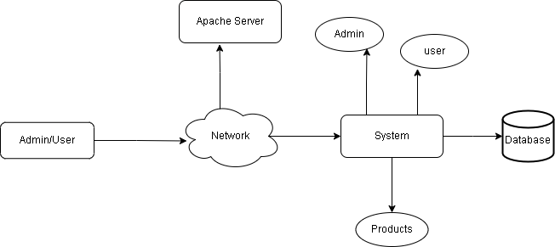

Figure 3:System Architecture of Himalayan Furniture

**Presentation Layer (Apache Server):**

The top tier is the presentation layer. It’s responsible for handling user interfaces (UIs) and interactions**.** In this case, the Apache Server represents the presentation layer. It serves web pages, processes user requests, and communicates with clients.

**Logic Layer (System):**

The middle tier is the logic layer (also known as the application server). Here, business logic, processing, and application functionality occur. The “System” element likely includes components like PHP scripts, application logic, and APIs. Users (both “Admin” and “User”) interact with this layer.

**Data Storage Layer (Database and Products):**

The bottom tier is the data storage layer. It houses databases (like MySQL) and data repositories. The “Database” element stores structured data (e.g., customer records, product details). The “Products” element might represent product catalog data.

### **2.4.2 DFD Level 0 Diagram**

The Himalayan Furniture e-commerce platform facilitates interactions between three main entities: Admin, Himalayan Furniture, and Customers. The admin can request login access and receive order information, while Customers can register, log in, and request specific products. The system responds to these requests accordingly. The DFD Level 0 Diagram for the Himalayan Furniture ecommerce system is clearly defined in the following figure 4.

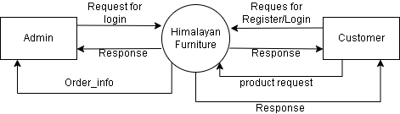

Figure 4:DFD Level 0 of Himalayan Furniture

### **2.4.3 DFD Level 1 Diagram**

The Data Flow Diagram (DFD) Level 1 for the Himalayan Furniture e-commerce system illustrates the key processes for both the admin and user roles. For the admin, the processes include login (1.0), managing categories (2.0), managing furniture (3.0), and managing orders (4.0). These processes allow the admin to handle the backend operations, ensuring that the product catalog is up-to-date and orders are efficiently processed. For the user, the processes include login/register (1.0), viewing products (2.0), adding products to the cart (3.0), placing orders (4.0), and making payments (5.0). This sequence guides the user through the entire shopping experience, from browsing products to completing purchases. The DFD visually outlines the flow of information between these processes, highlighting how user interactions lead to specific admin actions and system responses. The DFD Level 1 Diagram for the Himalayan Furniture ecommerce system is clearly defined in the following figure 5.

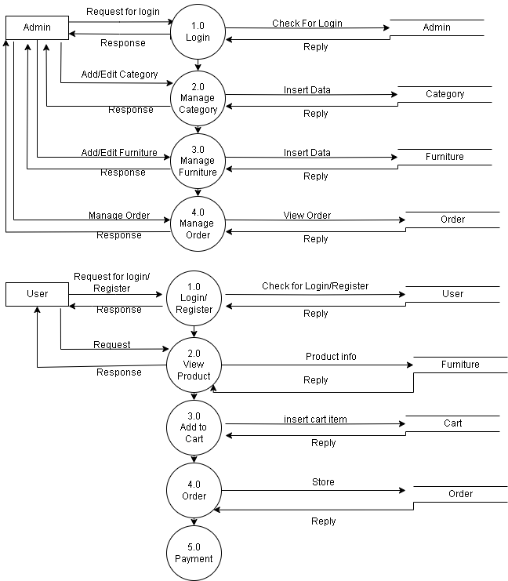

Figure 5:DFD Level 1 of Himalayan Furniture

### **2.4.4 DFD Level 2 Diagram**

The Data Flow Diagram (DFD) Level 2 for the Himalayan Furniture e-commerce system provides a detailed view of the processes involved for both the admin and user roles. For the admin, the processes include logging in (1.0), managing categories (2.0), managing furniture (3.0), and managing orders (4.0). These processes enable the admin to handle essential backend tasks such as updating product categories, adding or editing furniture items, and processing customer orders. For the user, the processes are more detailed, beginning with login/register (1.0), followed by viewing or searching products (2.0). Once the user identifies the desired products, they can add items to their cart (3.0). The cart management process is further broken down into reviewing the cart (3.1), entering shipping information (3.2), choosing a payment method (3.3), and placing the order (3.4). This detailed breakdown ensures a smooth and organized shopping experience for the user, guiding them through each step from browsing products to completing a purchase. The DFD highlights the interaction flow and data movement between these processes, emphasizing the system's comprehensive approach to handling both admin and user functionalities. The DFD Level 2 Diagram for the Himalayan Furniture ecommerce system is clearly defined in the following figure 6.

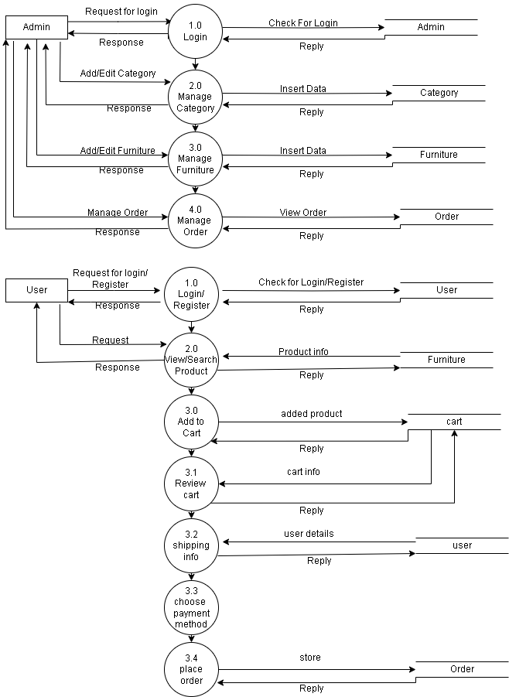

Figure 6:DFD Level 2 of Himalayan Furniture

### **2.4.5 ER Diagram**

This ERD represents a Himalayan Furniture ecommerce database where users can place orders for furniture items. Users and admins have distinct roles, with users creating accounts and logging in to place orders. An order consists of multiple items added to a cart, which is associated with a specific user. Each cart is linked to furniture items available in the store. The furniture items belong to various categories and have attributes like price and stock status. Admins manage the overall system, including user accounts and furniture inventory. The relationships in the diagram illustrate how users interact with the store, from adding items to a cart to completing an order.

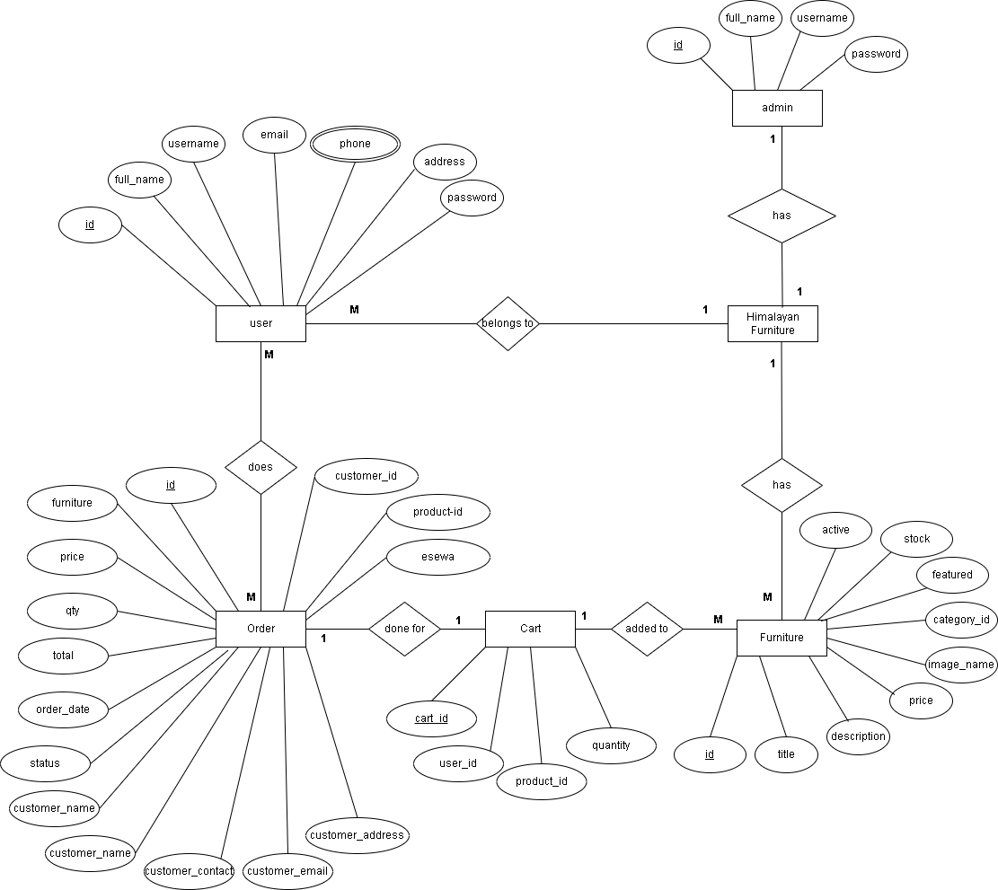

Figure 7: ER diagram of Himalayan Furniture

### **2.4.6 Database Schema**

This database schema represents a Himalayan Furniture ecommerce with tables for users, admins, orders, carts, furniture items, and categories. Users can place orders for furniture, and each order is linked to a specific user and furniture item, recording details like quantity, total price, and customer information. Users can add furniture items to their cart, which is linked to their user ID and the product ID of the furniture. The furniture table stores information about each furniture item, which belongs to a category defined in category. Admins manage the system through the admin table. Relationships are defined by foreign keys, indicating how users, orders, carts, furniture items, and categories are interconnected, facilitating the management of user accounts, orders, and inventory. The Database Schema for the Himalayan Furniture ecommerce system is clearly defined in the following figure 8.

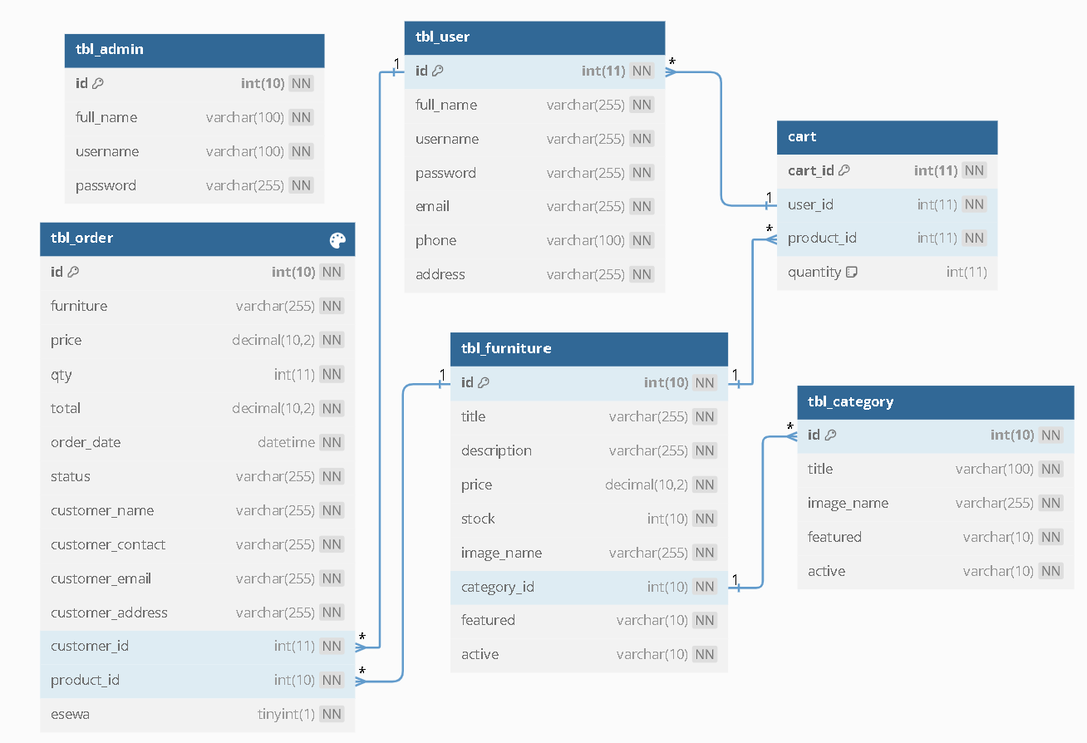

Figure 8:Database Schema of Himalayan Furniture

## **2.5 System Implementation**

### **2.5.1 System Development Methodology Used**

The Agile methodology was utilized for the development of the Himalayan Furniture e-commerce website. This approach was chosen for its ability to accommodate changes and deliver a high-quality product through iterative cycles.

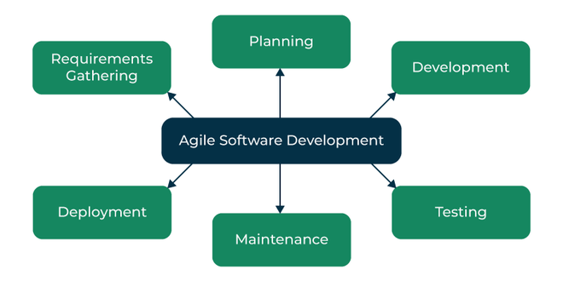

Figure 9: Agile Software Development

**Requirements Gathering:** The customer’s requirements for the software are gathered and prioritized.

**Planning:** The development team creates a plan for delivering the software, including the features that will be delivered in each iteration.

**Development:** The development team works to build the software, using frequent and rapid iterations.

**Testing:** The software is thoroughly tested to ensure that it meets the customer’s requirements and is of high quality.

**Deployment**: The software is deployed and put into use.

**Maintenance:** The software is maintained to ensure that it continues to meet the customer’s needs and expectations.

Following are the tools used for the accomplishment of this project:**Front End Tools**

**HTML**

For the Himalayan Furniture project, HTML served as the foundation for creating different webpages and sites. It helps structure various elements such as sections, headings, links, and paragraphs using different tags. Additionally, HTML is used to define key components like headers, paragraphs, links, and images, ensuring clarity and organization on the Himalayan Furniture ecommerce website.

**CSS**

In this project primarily utilized CSS3 to design the overall appearance and style. This includes implementing hovering effects on the carousel, enabling dynamic changes to carousel images, adjusting font sizes, specifying text colors for paragraphs, headings, and table content, as well as managing margins, paddings, and various other styling elements.

**JavaScript**

In the Himalayan Furniture project, JavaScript is employed for client-side validation and to create dynamic, interactive, and responsive web pages. It is utilized to introduce dynamic behaviors and special effects to enhance the overall user experience on the website

**Back End Tools**

**PHP**

In the Himalayan Furniture project, PHP served as the backend scripting language for creating dynamic web pages. It is responsible for server-side scripting tasks such as establishing connectivity with the database, encrypting data, validating user input, controlling access to certain pages, and managing functionalities like user login. Additionally, PHP facilitates operations like adding, updating, and deleting data from the database to ensure smooth data management on the website**.**

**Server**

**Apache Server**

In the Himalayan Furniture project, an Apache server is used to execute PHP files, enabling the creation of fast and dynamic web pages.

**Database**

MySQL is used in the Himalayan Furniture project to store all the necessary information in the database. It facilitates CRUD operations, allowing users to create, read, update, and delete data from the database as needed.

### **2.5.2 Modules Description**

Different modules of this system are described as below:

**Admin Modules**

* **Admin add/edit/delete Products**

In this module, there are different categories for products. The admin can add, list, update, and delete the products in this existing system. The admin initiates the action by clicking on the "Add Product" button to add a product category. The admin can perform edit and delete actions by clicking the "Edit" and "Delete" buttons respectively. Then, the admin selects the product category they want to edit or delete by clicking on the corresponding buttons**.**

* **Admin manage orders**

In this module, the admin manages orders by either canceling or confirming the orders requested by users in the user module. It includes fields such as name, mobile number, email ID, and status. In the status section, if the admin confirms the order made by the user, the status will be updated to "confirmed," and the user in the user module can view that it is confirmed.

* **Manage Users**

In the Manage Users module, the admin oversees user management tasks, including activating or deactivating user accounts as required.

**User module**

* **Register module**

This Register Module allows users to create a new account by entering their name, email, and password. This information is securely stored in the system's database, enabling users to access the system's features after registration.

* **Login Module**

This Login Module allows users to enter their registered username and password to access the system securely. It verifies the credentials against stored data and grants access if they match, ensuring only authorized users can log in and use the system's features.

* **Ordering**

In the Ordering Module, users can purchase furniture products by providing essential details such as their name, address, and phone number, along with the desired product's name and quantity. This module facilitates the seamless process of placing orders, ensuring that users can easily select the products they want and specify the necessary delivery information.

* **Payment Processing**

In the Payment Processing Module, users finalize their purchase of furniture products by either using an external payment option, such as E-Sewa Testing API, or opting for offline payment methods. After placing their order, users are directed to the payment page where they can securely complete their transaction using the integrated external payment system. Alternatively, users may choose to pay offline, perhaps through methods like cash on delivery or bank transfer.

* **Print Bill**

In the Print Bill Module, users can access and download/print the bill for their ordered products after completing the purchase. Once an order is placed, users are provided with the option to view and download/print the bill, which includes details such as the ordered products, quantities, prices, and total amount.

## **2.6 System Testing**

Software testing is the process of evaluating the differences between the given input and the expected output. During the testing process, I verify whether all elements in the Himalayan Furniture ecommerce platform are functioning correctly or not.

### **2.6.1 Unit testing with test cases**

Unit testing is a level of software testing where individual units/components of a software are tested. The purpose is to validate that each unit of the software performs as designed. It was tested whether all the elements in the specific design layout are working or not. Various units or modules to be tested are:

Table 1:Test Case for Admin Loging and Logout

|  |  |  |  |  |
| --- | --- | --- | --- | --- |
| **Test Case**  **ID** | **Test Description** | **Input** | **Expected Result** | **Test Result** |
| TC-1 | Successful Admin Login | Username: bishal,  Password: bishal | Successful Login of  admin | Admin successfully logged in |
| TC-2 | Admin Login Fail | Username: admin, Password:2345 | A message “Please enter the correct username and password” should be displayed. | A message “Please enter the correct username and password” is displayed |
| TC-3 | Successful  Admin  Logout | Click logout  option | The page should be  redirect to admin  login page | The page redirected to admin login page |

Table 2:Test Case for User Registration/Signup

|  |  |  |  |  |
| --- | --- | --- | --- | --- |
| **Test Case**  **ID** | **Test Description** | **Input** | **Expected Result** | **Test Result** |
| TC-1 | Successful  User  Registration | Full Name:Bishal Dhakal  Username: bishal,  Email: [bishaldkl56@gmail.com](mailto:bishaldkl56@gmail.com)  Address: Kathamandu  Phone:9810041458  Password: bishaldkl1@  Confirmpass:bishaldkl1@ | It Should redirect to user login page. | It was redirect to user login page. |
| TC-2 | Enter  Different password and confirm password | Full Name:Bishal Dhakal  Username: bishal,  Email: [bishaldkl56@gmail.com](mailto:bishaldkl56@gmail.com)  Address: Kathamandu  Phone:9810041458  Password: bishaldkl@  Confirmpass:bishaldkl1@ | A message “Please enter the correct username and password” should be displayed. | A message “Please enter the correct username and password” is displayed |
| TC-3 | Leave username and  password  field empty  and Signup | Full Name:Bishal Dhakal  Username:  Email: bishaldkl56@gmail.com  Address: Kathamandu  Phone:9810041458  Password:  Confirmpass:bishaldkl1@ | Error Message “please fill all the fields”  should be displayed. | Error Message “please fill all the fields”  is displayed. |

Table 3:Test Case for User Login and Logout

|  |  |  |  |  |
| --- | --- | --- | --- | --- |
| **Test Case**  **ID** | **Test Description** | **Input** | **Expected Result** | **Test Result** |
| TC-1 | Successful  User Login | Username: bishal  Password: bishaldkl1@ | The login page should redirect to  home page. | The login page  should redirect to home page. |
| TC-2 | Enter Invalid username and password. | Username: Bishal,  Password: Bishaldkl@ | Error message “username or password didn’t match” should be displayed. | Error message “username or password didn’t match” displayed. |
| TC-3 | Leave student id and password fields empty. | Username:  Password: | Error message “username or password didn’t match” should be displayed. | Error message “username or password didn’t match” displayed. |
| TC-4 | Successful  User Logout | Click Logout option | The page should  redirect to  homepage. | The page redirect to  homepage. |

Table 4: Test Case for Search

|  |  |  |  |  |
| --- | --- | --- | --- | --- |
| **Test Case**  **ID** | **Test Description** | **Input** | **Expected Result** | **Test Result** |
| TC-1 | Searching | Search  Keyword:  “chair” | All the Furniture whose name contains the  keyword “chair” should be displayed. | All the book whose name contains the  keyword “chair” is displayed |
| TC-2 | Searching  failed | Search Keyword: “food” | A message “Furniture not  Found” should be  displayed | A message “furniture not Found” is displayed |

Table 5:Test Case for add to cart

|  |  |  |  |  |
| --- | --- | --- | --- | --- |
| **Test Case**  **ID** | **Test Description** | **Input** | **Expected Result** | **Test Result** |
| TC-1 | Add to cart  Without login. | Click add to cart button | A popup message “Login is required to add this product into cart.” Should be displayed. | A popup message “Login is required to add this product into cart.” is displayed. |
| TC-2 | Add to cart after login. | Click add to cart button | Bucket button value should be increased by 1, | Bucket button value is increased by 1, |

Table 6: Test Case for Order

|  |  |  |  |  |
| --- | --- | --- | --- | --- |
| **Test Case**  **ID** | **Test Description** | **Input** | **Expected Result** | **Test Result** |
| TC-1 | Cash on Delivery | Fill the form like  Name, address and phone number and click the cash on delivery button | The page should be redirect to customer order page and show the order item with message “Thanks! for your order, It will be delivered within 7 working days.” Should be displayed and sent order conformation message to the mail. | The page should be redirect to customer order page and show the order item with message “Thanks! for your order, It will be delivered within 7 working days.” Is displayed and order confirmation mail received. |
| TC-2 | Pay with e-sewa | Fill the form like  Name, address and phone number and click the pay with esewa button. | The page should be redirect to esewa login page and after successful payment page should be redirect to customer order page with order product and sent order conformation message to the mail. | The page should be redirect to esewa login page and after successful payment page is redirect to customer order page with order product and order confirmation mail received. |

### **2.6.2 Integration testing with test cases**

The system was tested again to know whether it is functioning properly or not after integration. In integration Testing units have been generalized; admin login, update furniture, update orders, user login, add to cart and order.

Table 7:Test Case for Integration

|  |  |  |  |
| --- | --- | --- | --- |
| **Test**  **Cases** | **Input** | **Expected Result** | **Test Result** |
| Admin Login | Username: bishal  Password: bishal | Admin panel should be displayed. | Admin panel is displayed. |
| Furniture Update | Add, delete or edit  Furniture. | Furniture should be added to the database and displayed to the  browser, should be  edited and deleted on click. | Furniture is added to the  database, edited and  deleted. |
| Update order | Delivered, On delivery, canceled the Order. | Order should be update according to the time and can be canceled when customer request. | Order is update according to the time and can be canceled when customer request. |
| User Login | Username: bishal  Password: bishal1@ | Account page with account information should be displayed. | Account page with account information is displayed. |
| Add to cart | Select the furniture and click add to cart button. | Furniture should be added to the cart. | Furniture is added to the cart. |
| Order | Fill the necessary firm and click either cash on delivery or pay with esewa button. | Order should be placed according to the user choice and after successful order item must be displayed on user orders page and send order conformation mail. | Order should be placed according to the user choice and after successful order item is displayed on user orders page and send order conformation mail. |

# CHAPTER 3

# DISCUSSION AND CONCLUSION

## **3.1: Conclusion**

The successful implementation of the Furniture Shop Ecommerce Website for Himalayan Furniture marks a significant milestone in enhancing customer satisfaction and modernizing business operations. The primary objective of improving the shopping experience has been achieved by providing a user-friendly platform where customers can effortlessly browse and purchase furniture. This digital transformation aligns Himalayan Furniture with contemporary market trends, making shopping easier through a secure online store with a robust payment gateway. The system also streamlines administrative tasks, allowing efficient management of product categories, inventory, and orders while providing real-time sales data. Additionally, the scalable design ensures that the company can handle increasing traffic and sales volumes, supporting regional and international market expansion. By offering valuable customer insights, the platform enables tailored marketing strategies and optimized inventory management. Overall, the e-commerce website positions Himalayan Furniture as a forward-thinking, customer-centric company ready to thrive in the competitive online marketplace, ensuring future growth and success.

## **3.2: Lesson Learnt**

During the project, the task of integrating a payment gateway into the Himalayan Furniture website presented a notable challenge. Initially, the selected payment gateway didn't integrate smoothly with the website's existing framework, leading to persistent errors and disruptions during transactions. To overcome this obstacle, an exhaustive exploration process was initiated, involving in-depth research into alternative payment solutions and engaging in discussions with various payment gateway providers. These efforts aimed to identify a compatible solution that would seamlessly integrate with the website platform. Furthermore, extensive testing procedures were meticulously executed to validate the functionality and reliability of the payment system. This comprehensive testing phase involved simulated transactions under various scenarios to ensure robustness and stability. Through diligent testing and collaborative problem-solving, the issues were gradually addressed, and the payment gateway was successfully integrated into the website, ensuring seamless and error-free transactions for customers. This experience underscored the critical importance of thorough research, testing, and effective communication in resolving technical challenges and delivering a dependable ecommerce platform for Himalayan Furniture customers.

## **3.3: Recommendations**

For enhancing the Himalayan Furniture e-commerce website, the following key features are recommended:

* **Integrate One-Time Password Feature**

Enhance security during login and transactions by adding an extra layer of protection for users' accounts and sensitive information.

* **Incorporate Customer Rating Options**

Improve the shopping experience by allowing shoppers to make informed decisions based on peer reviews and experiences, building trust and fostering a sense of community among customers.

* **Introduce Wishlist Functionality**

Help users to save desired items for future purchase, streamlining their shopping journey and encouraging repeat visits to the website.

# REFERNCES

*Online Shopping in Nepal | Best Deals, Prices & Discounts - Daraz.com.np*. (n.d.). <https://www.daraz.com.np/>

*SB Furniture Nepal: Home & Office Furniture And Decor*. (n.d.). S.N. Joshi & Sons Company Pvt. Ltd. <https://sbfurniturenepal.com/>

*Furniture Hub | Best Furniture Store in Nepal*. <https://www.furniturehub.com.np/>

*Home - Funfurnish | Nepal's Largest Online Furniture Showroom*. Funfurnish | Nepal's Largest Online Furniture Showroom. <https://funfurnish.com/>

Sommerville, I.. (2011). *Software Engineering* (9th ed.). Pearson.

# 

# APPENDICES

**Application UI and System Snapshots**

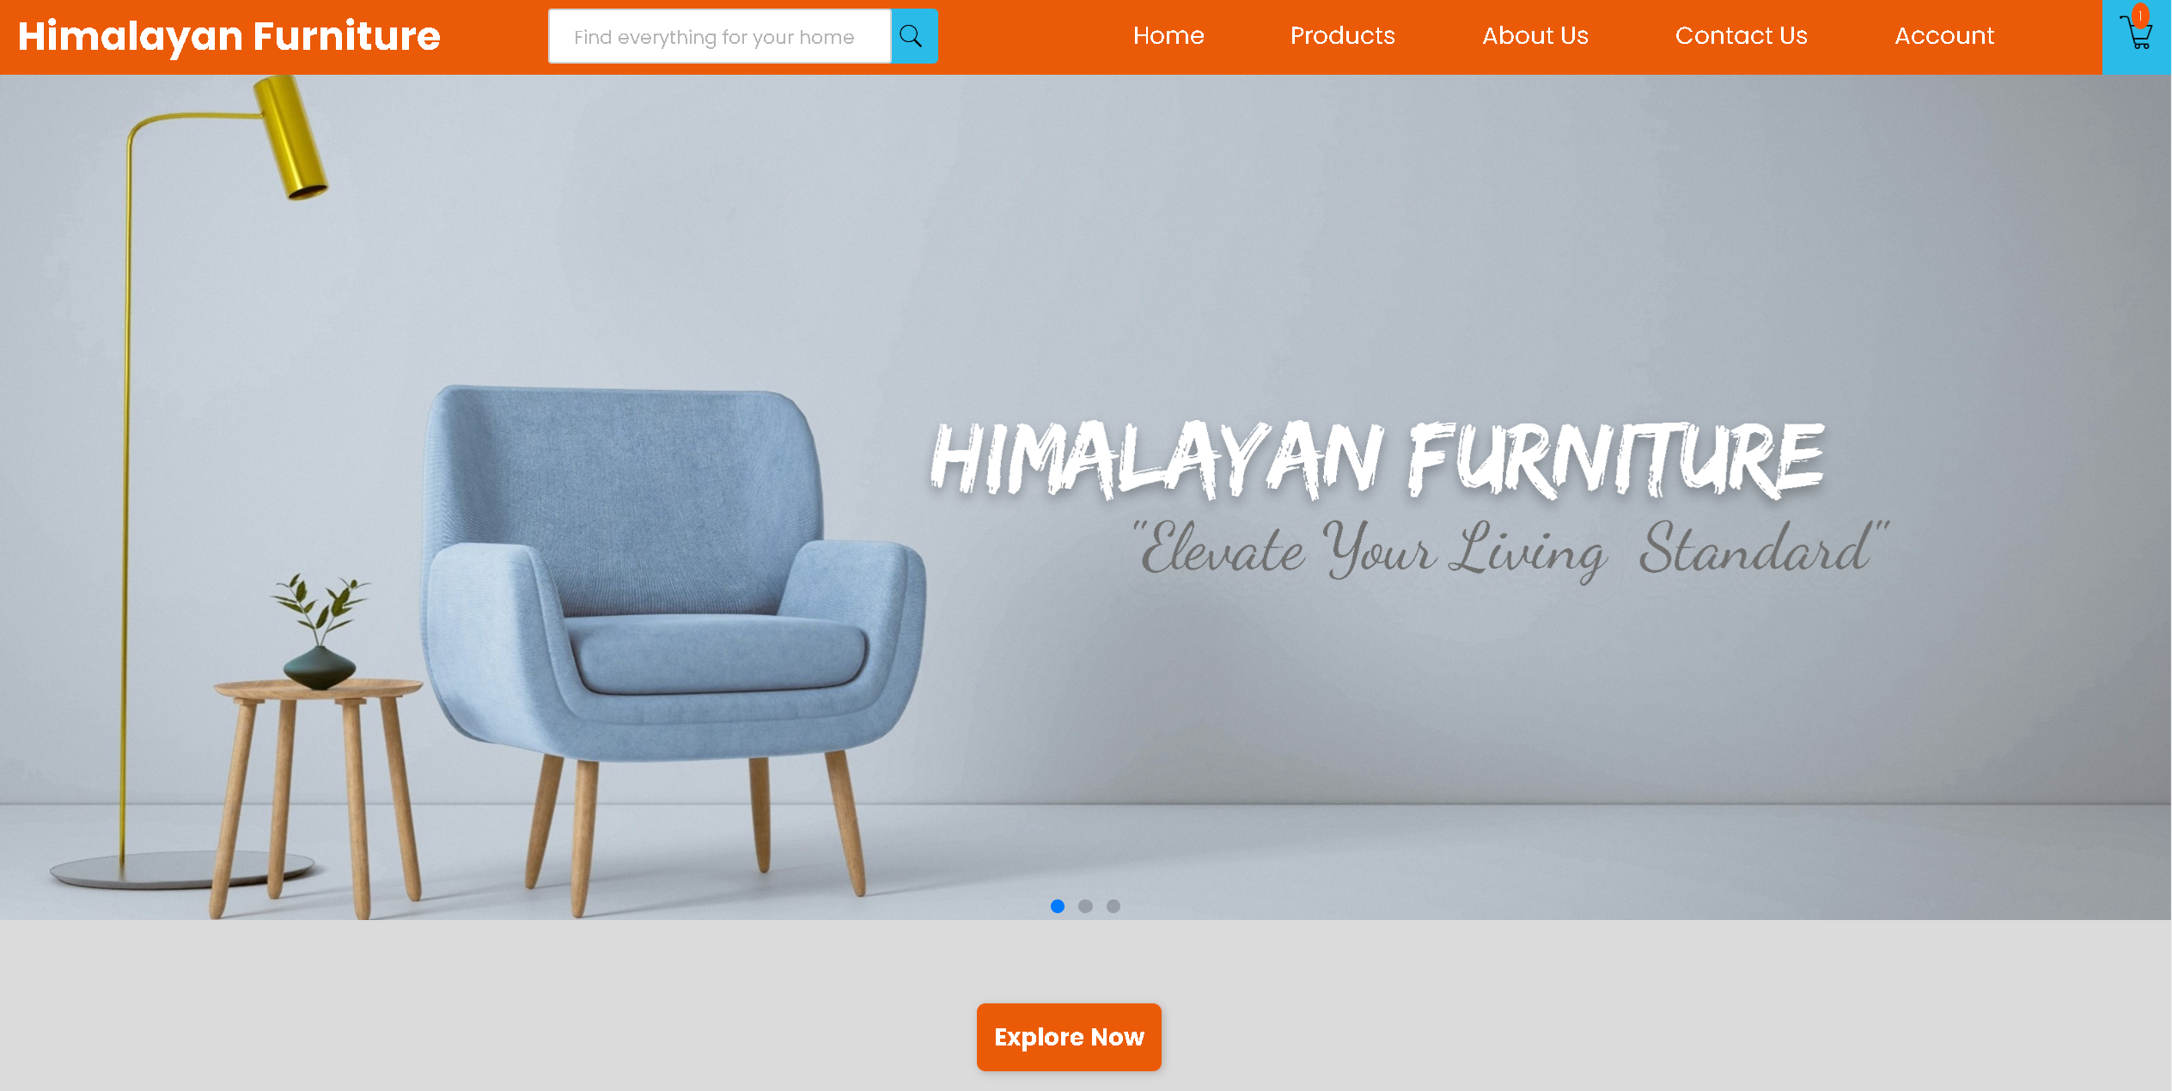

Home page

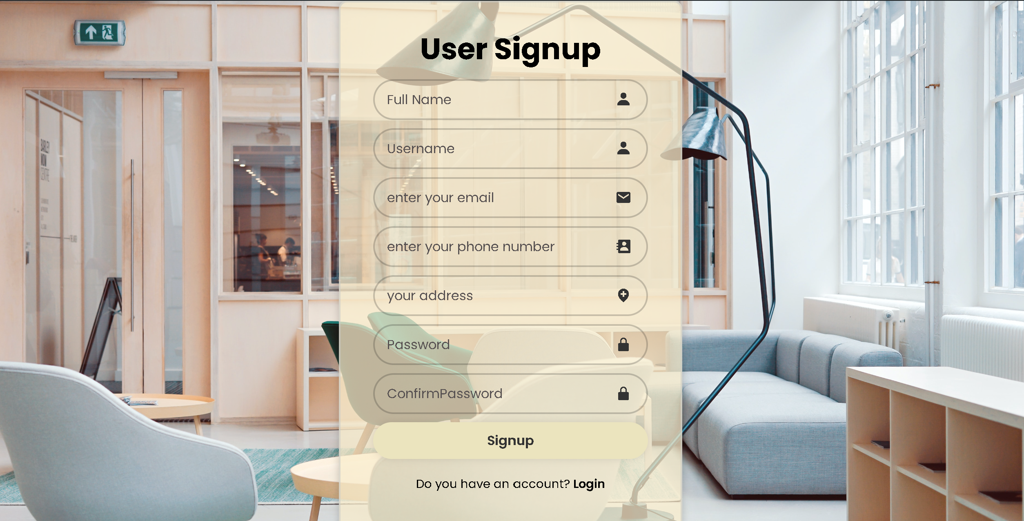

Signup page

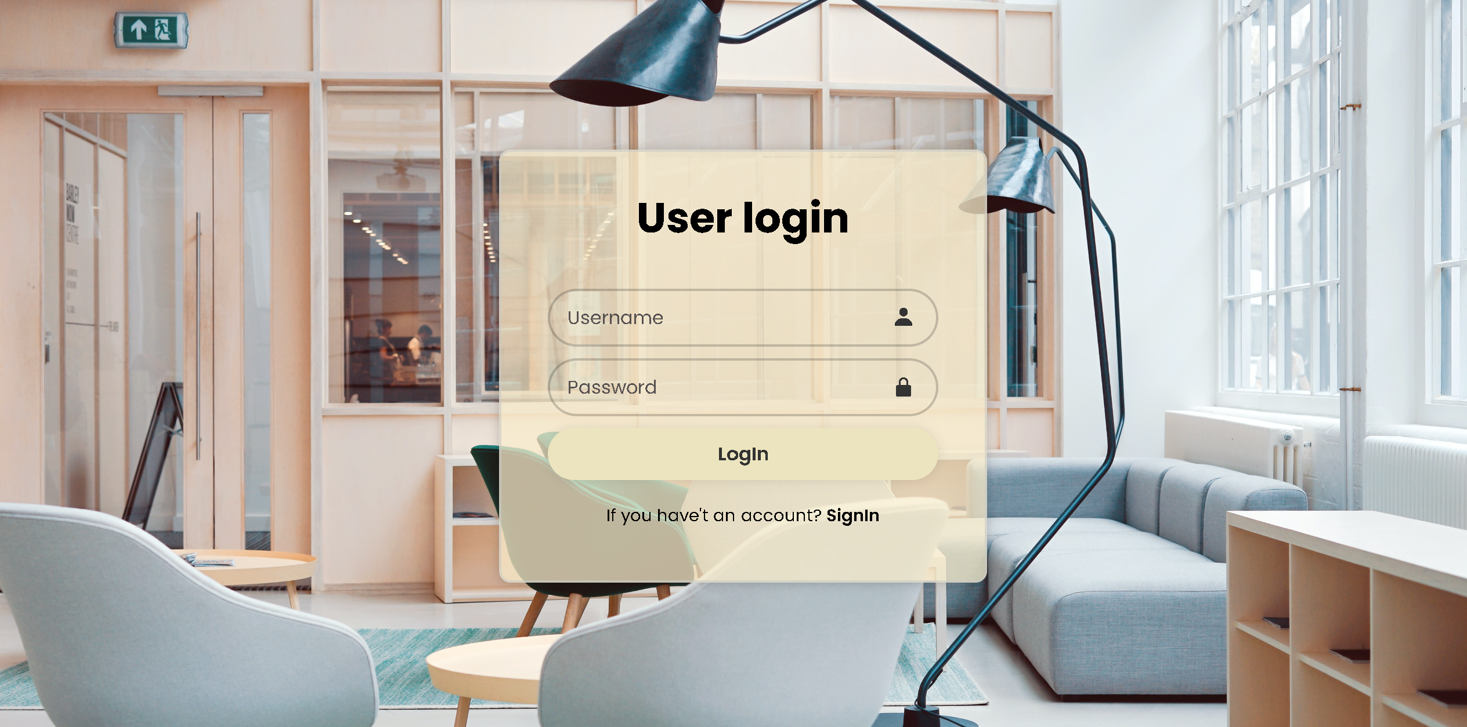

Login page

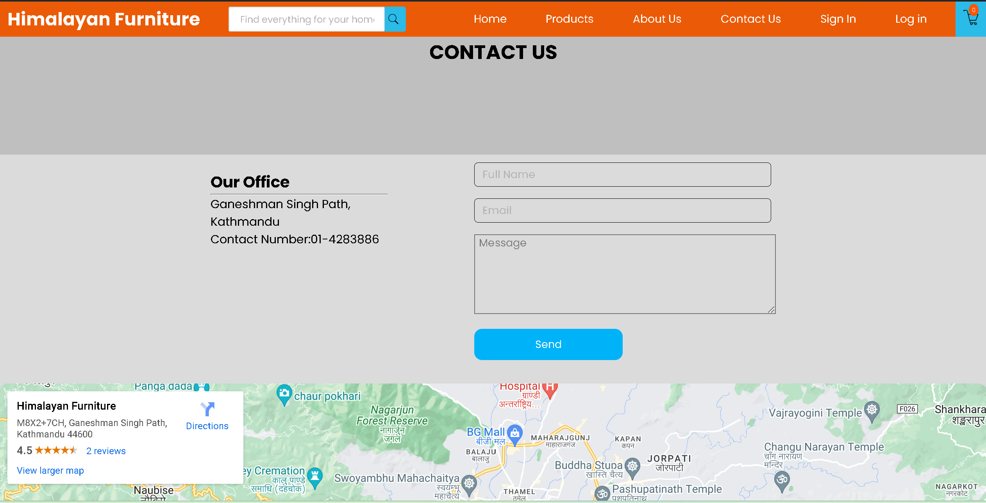

Contact Us page

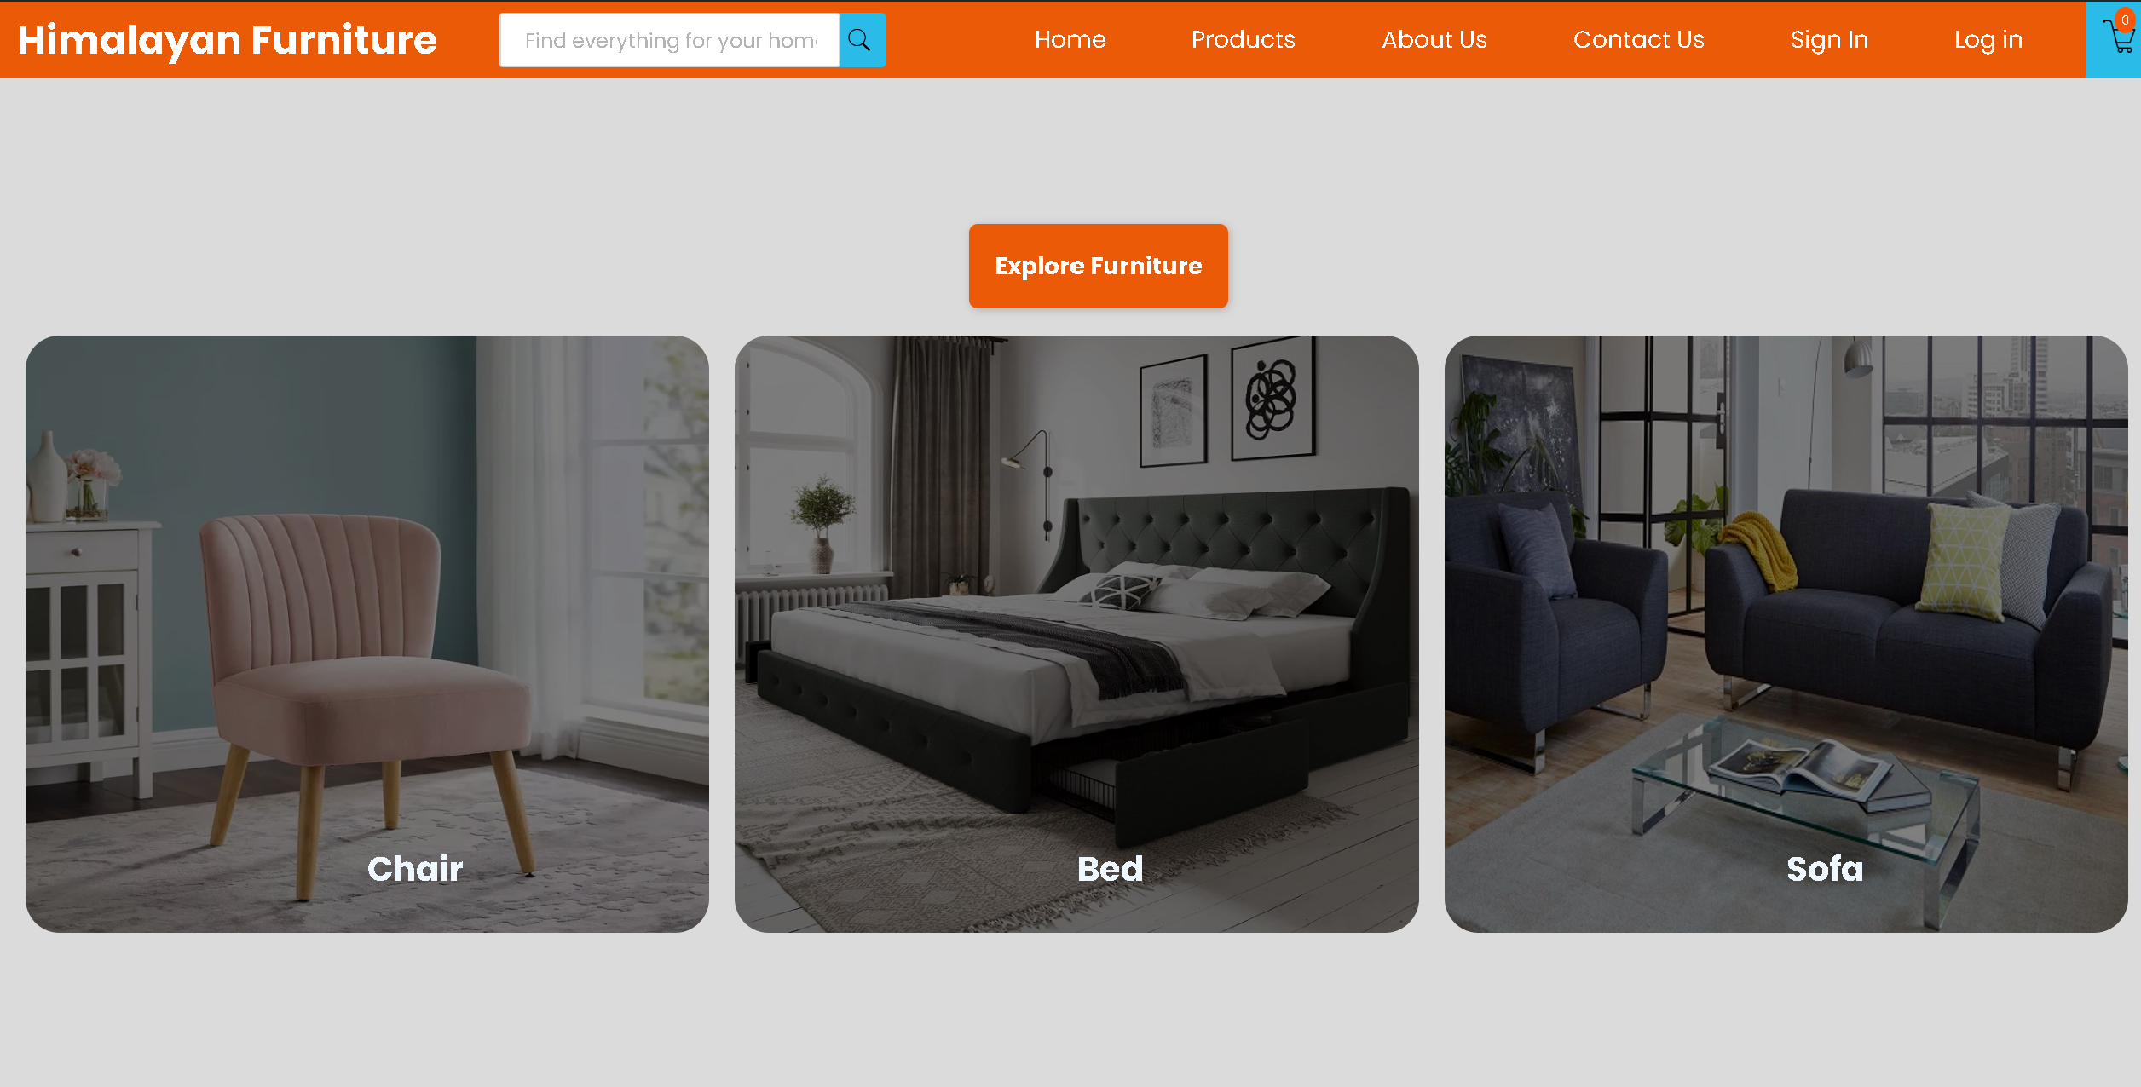

Product page

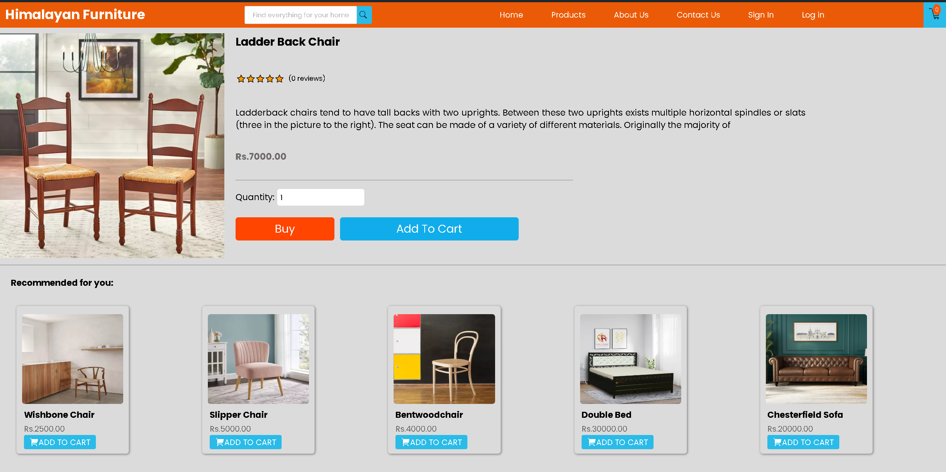

Furniture detail page

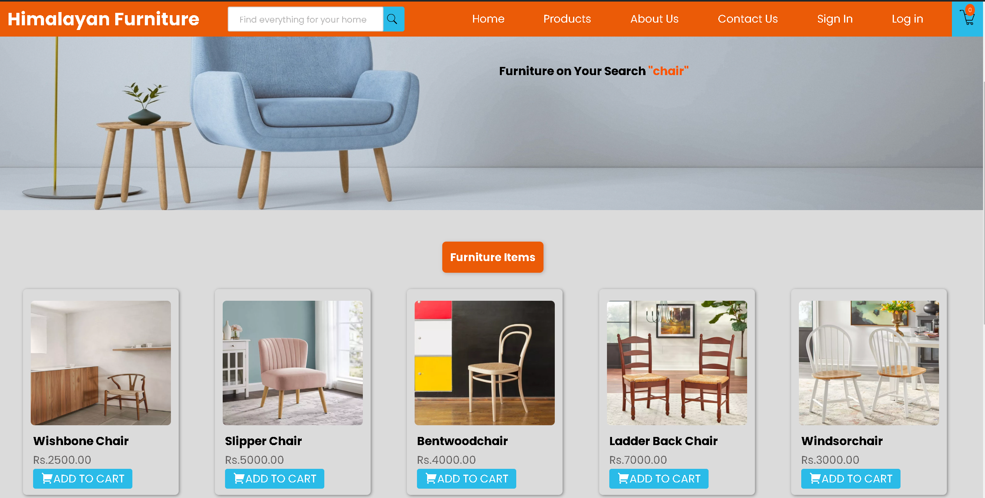

Search page

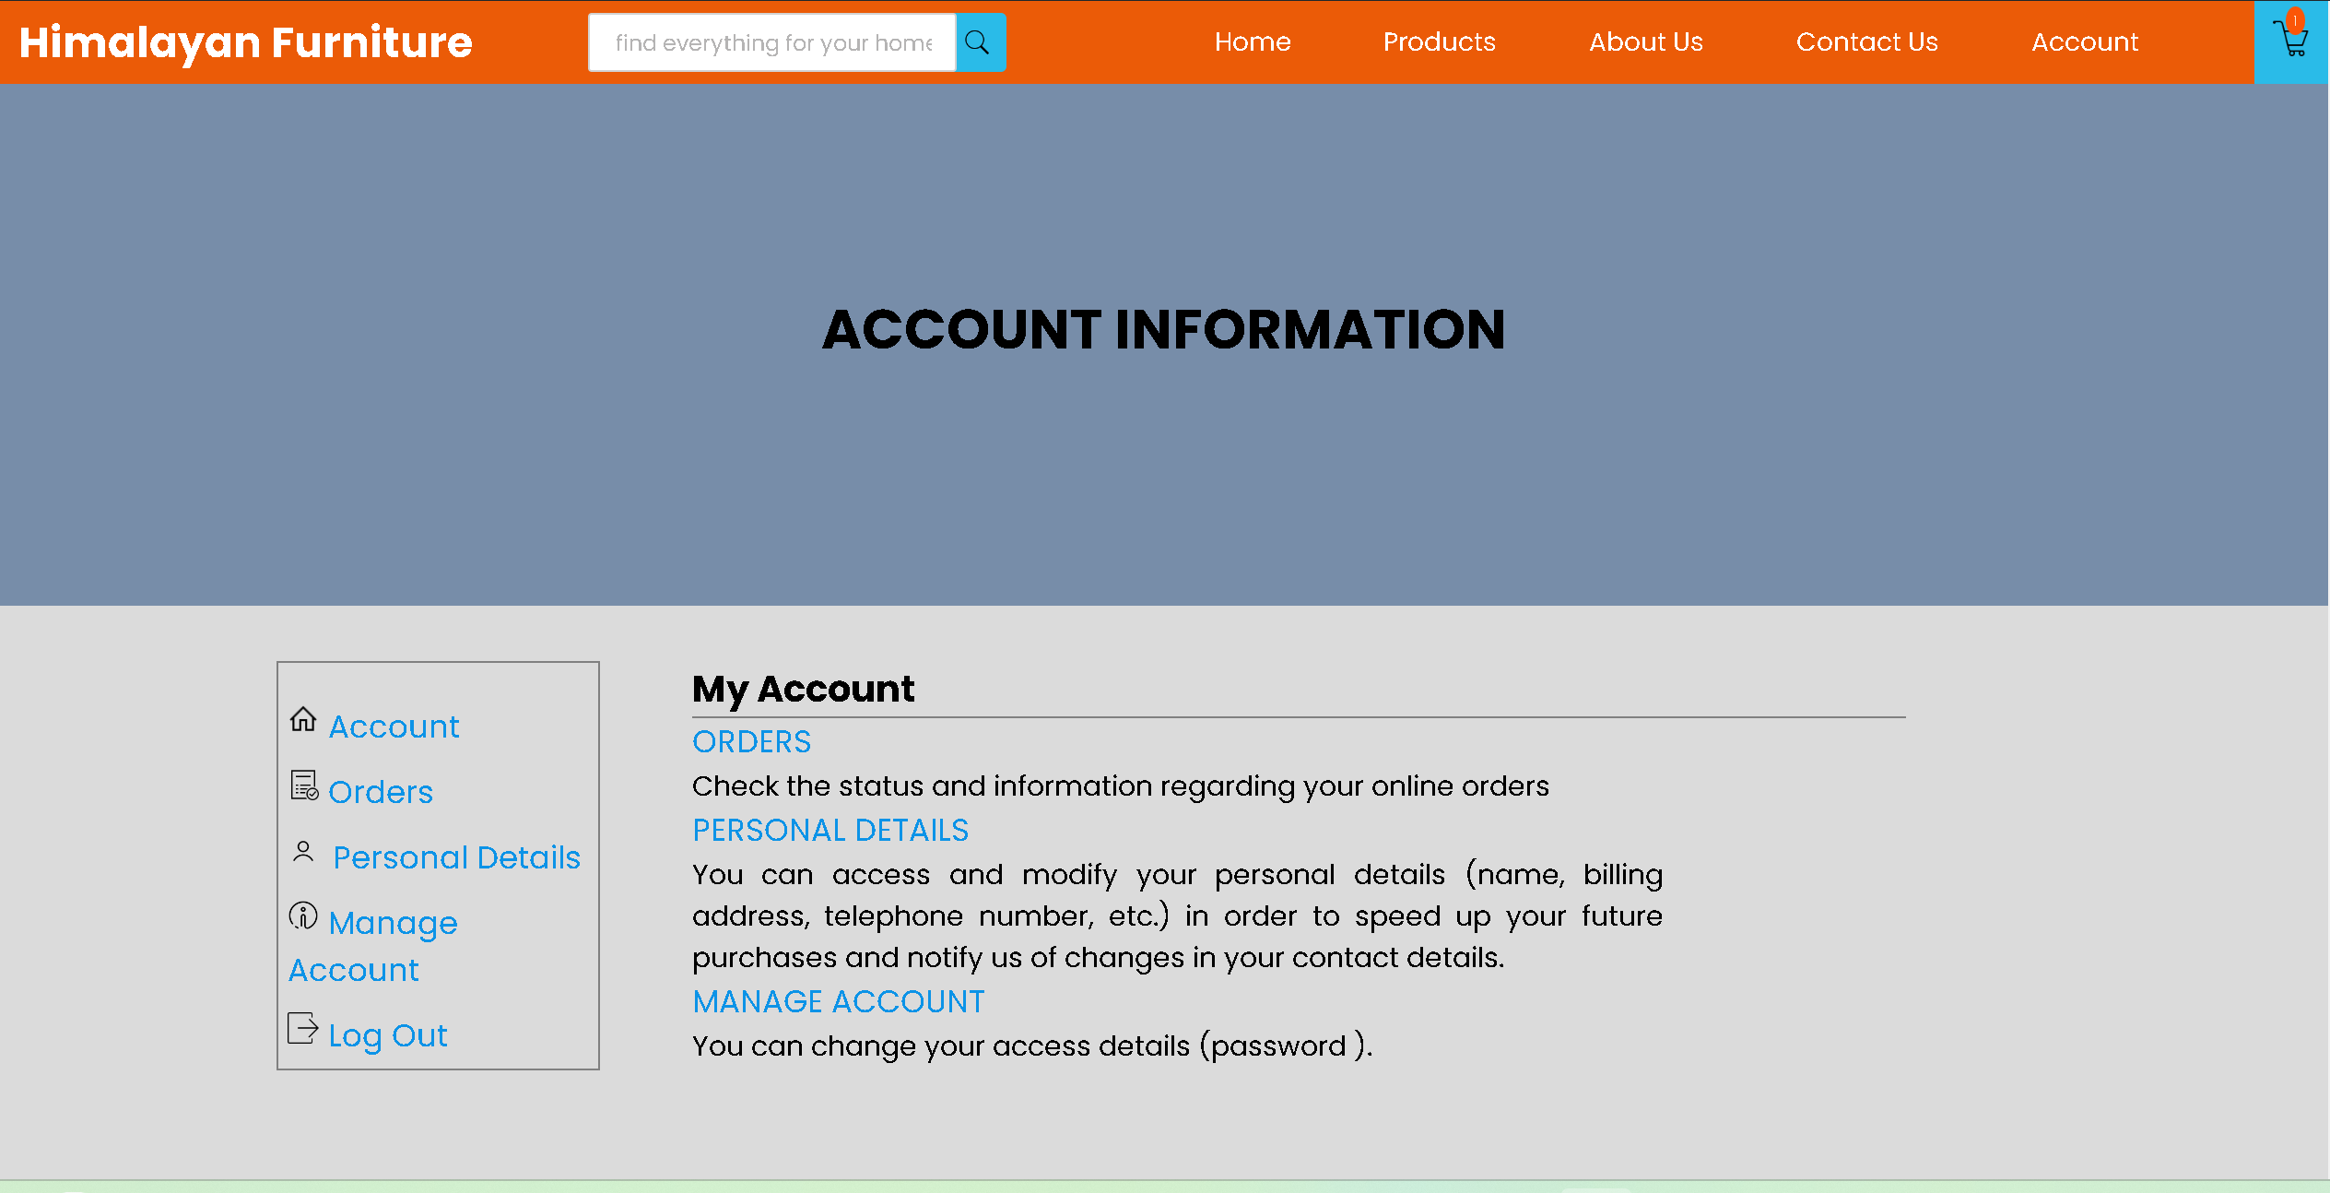

Account page

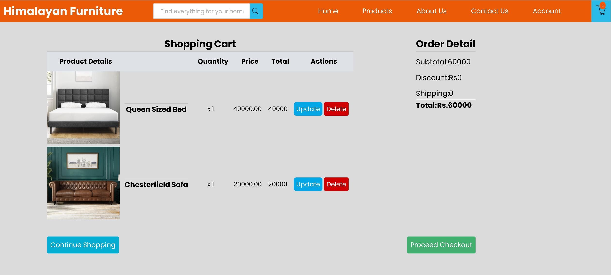

Cart page

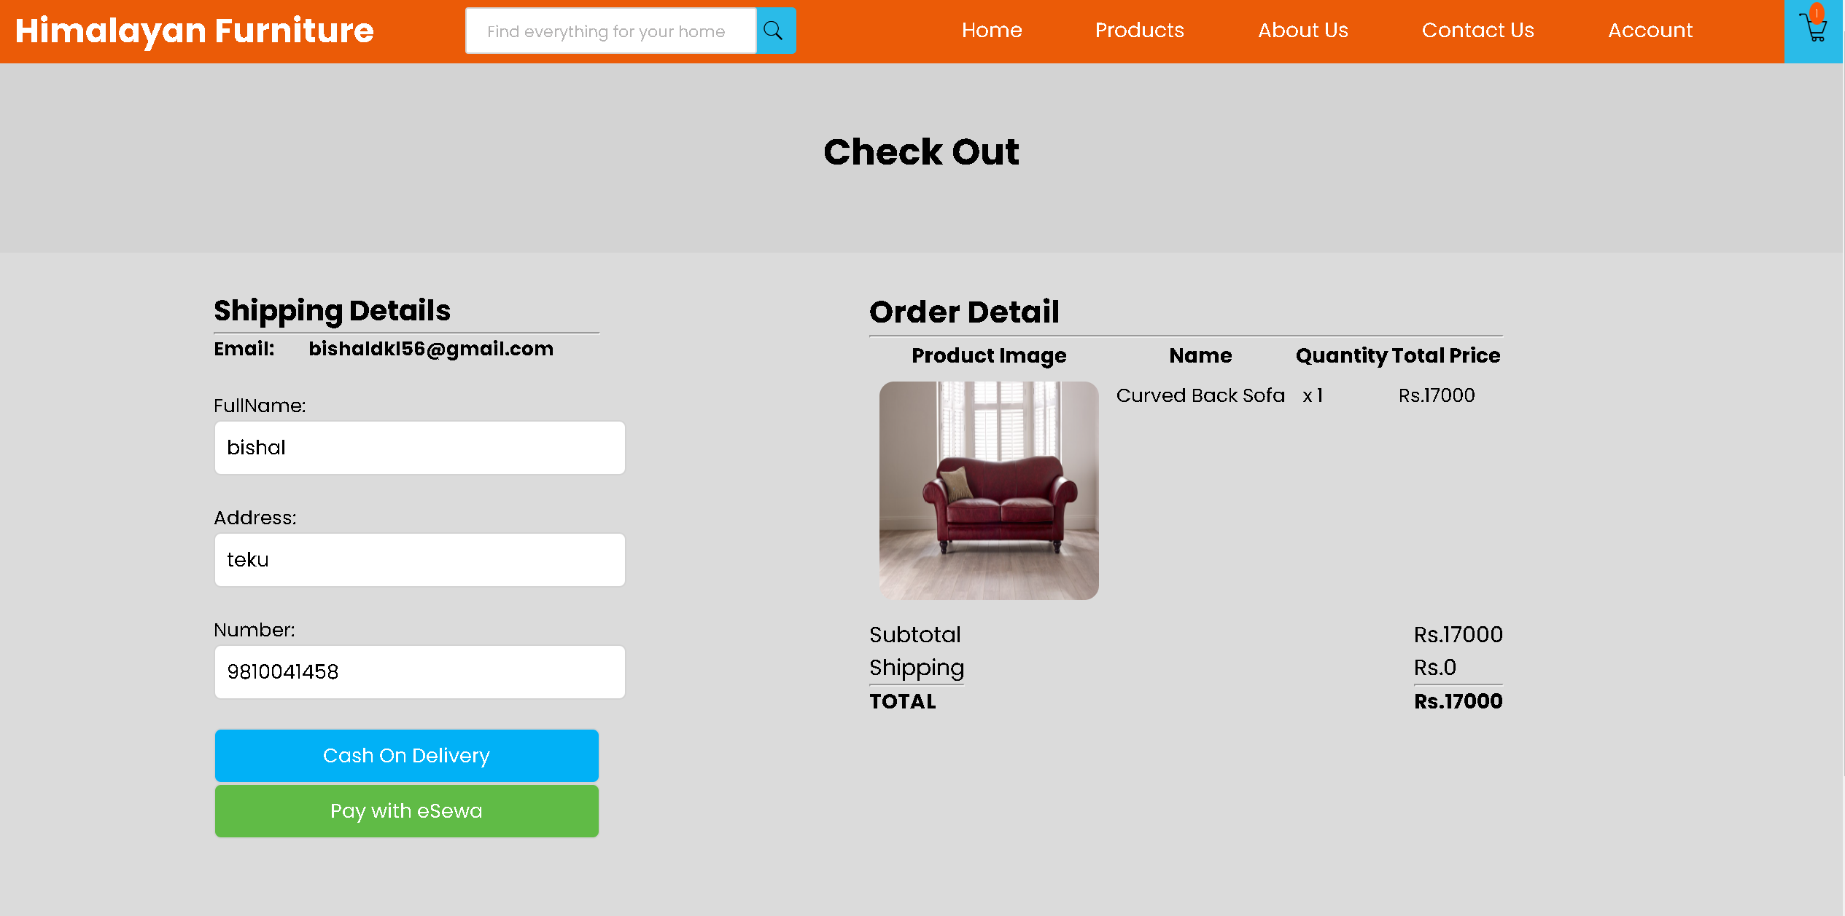

Checkout Page

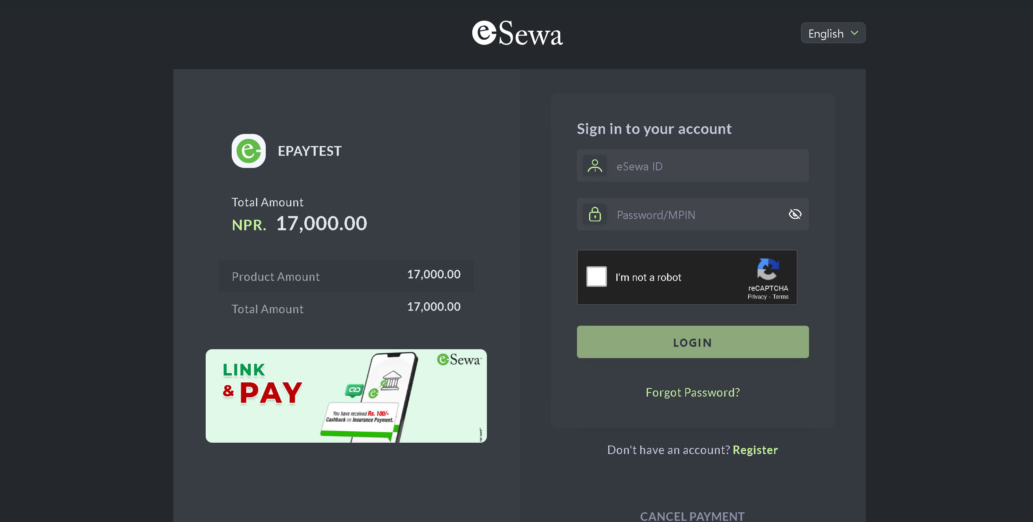

Esewa Testing API for Payment

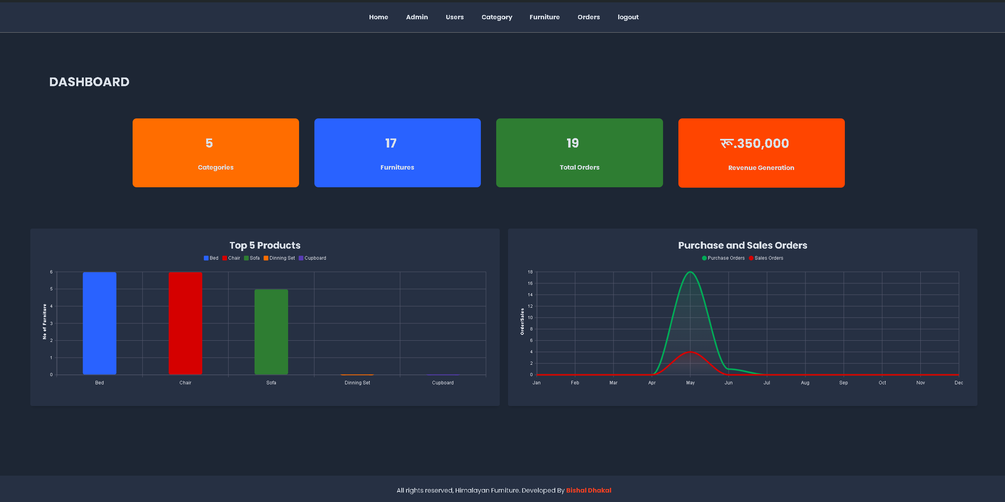

Admin Dashboard